Prediction of economic indicator using ARIMA

## The historical data over time

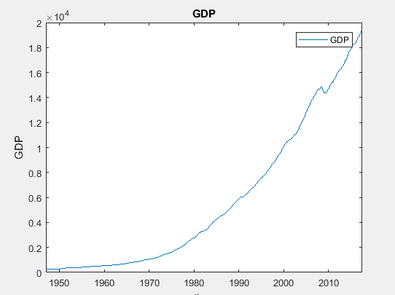

## The first differenced GDP which is stationary

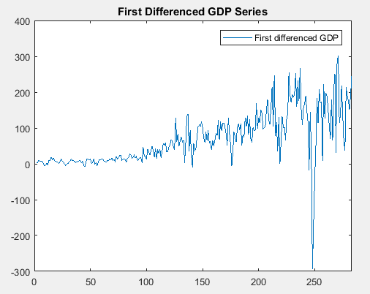

## Plotting the ACF and PACF

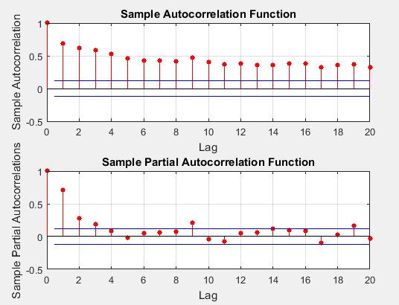

## Checking the normality of residuals

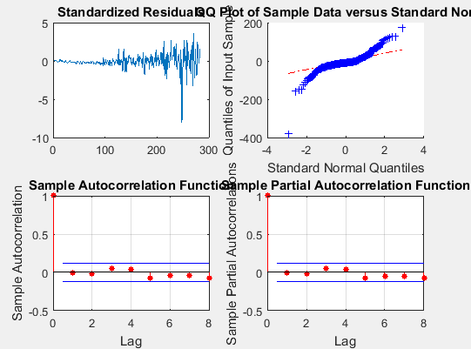

## Forecasted GDP

